Map Switch Installation

Document Version | 1 | Release Date | 05 March 2019

Application information | Generic
Vehicle | Not Applicable
Model | Not Applicable
Year of manufacture | Not Applicable
PowerTRONIC application | All PowerTRONIC ECUs, from firmware version F.3.x onward

Note:

- Read through all instructions before installation and use.
- Ensure that the bike is switched off and the key is out of the ignition before proceeding with the installation.
- Some parts of the bikes might be hot/sharp and may cause burns/cuts. Proceed with extreme caution or wait until the bike has cooled down. Always wear safety gloves.
- When the installation is complete, make sure to secure the wiring loom away from the movable parts or components which tends to heat up during the normal operation of the vehicle at any chance.
- PowerTRONIC is intended for motorsport use on a closed course, please check with your local laws before using this product. Race Dynamics / PowerTRONIC is not liable for consequences arising out of using the product.

Support

Call/Whatsapp: +91 99162 29292 / +91 80409 29292
E-Mail: support@powertronicECU.com
Website: www.powertronicECU.com

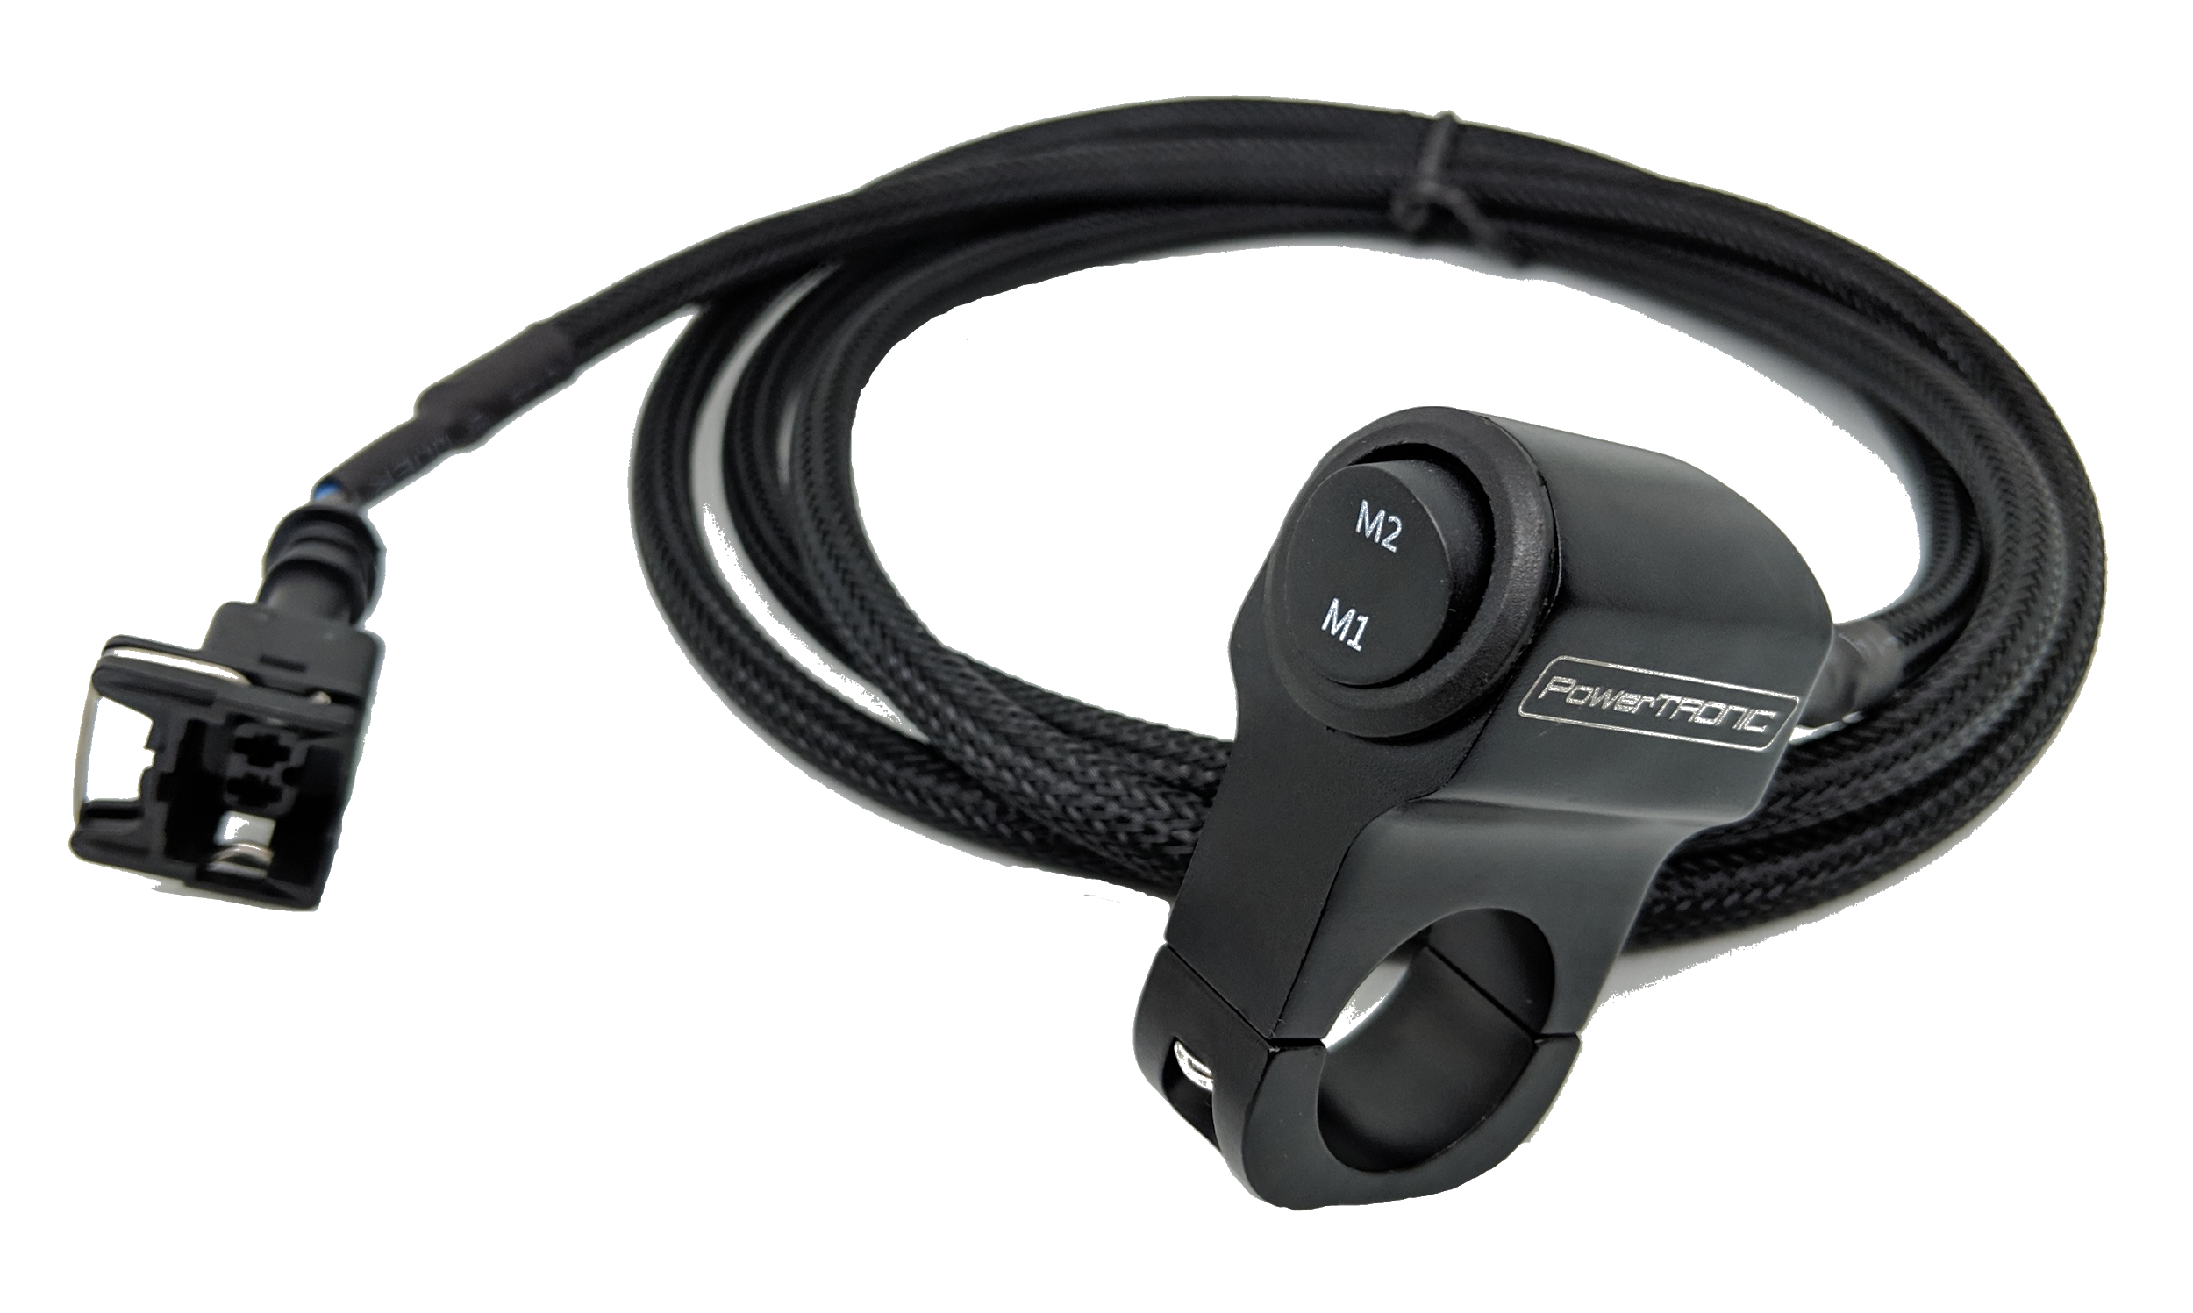
Tools Required
- Allen key
- Phillips head Screwdriver
- Pliers
- Cutters/Wire Strippers
Map Switch Installation procedure
Step 1: Attach the map selector to the handle bar using screws. (Refer figure below)
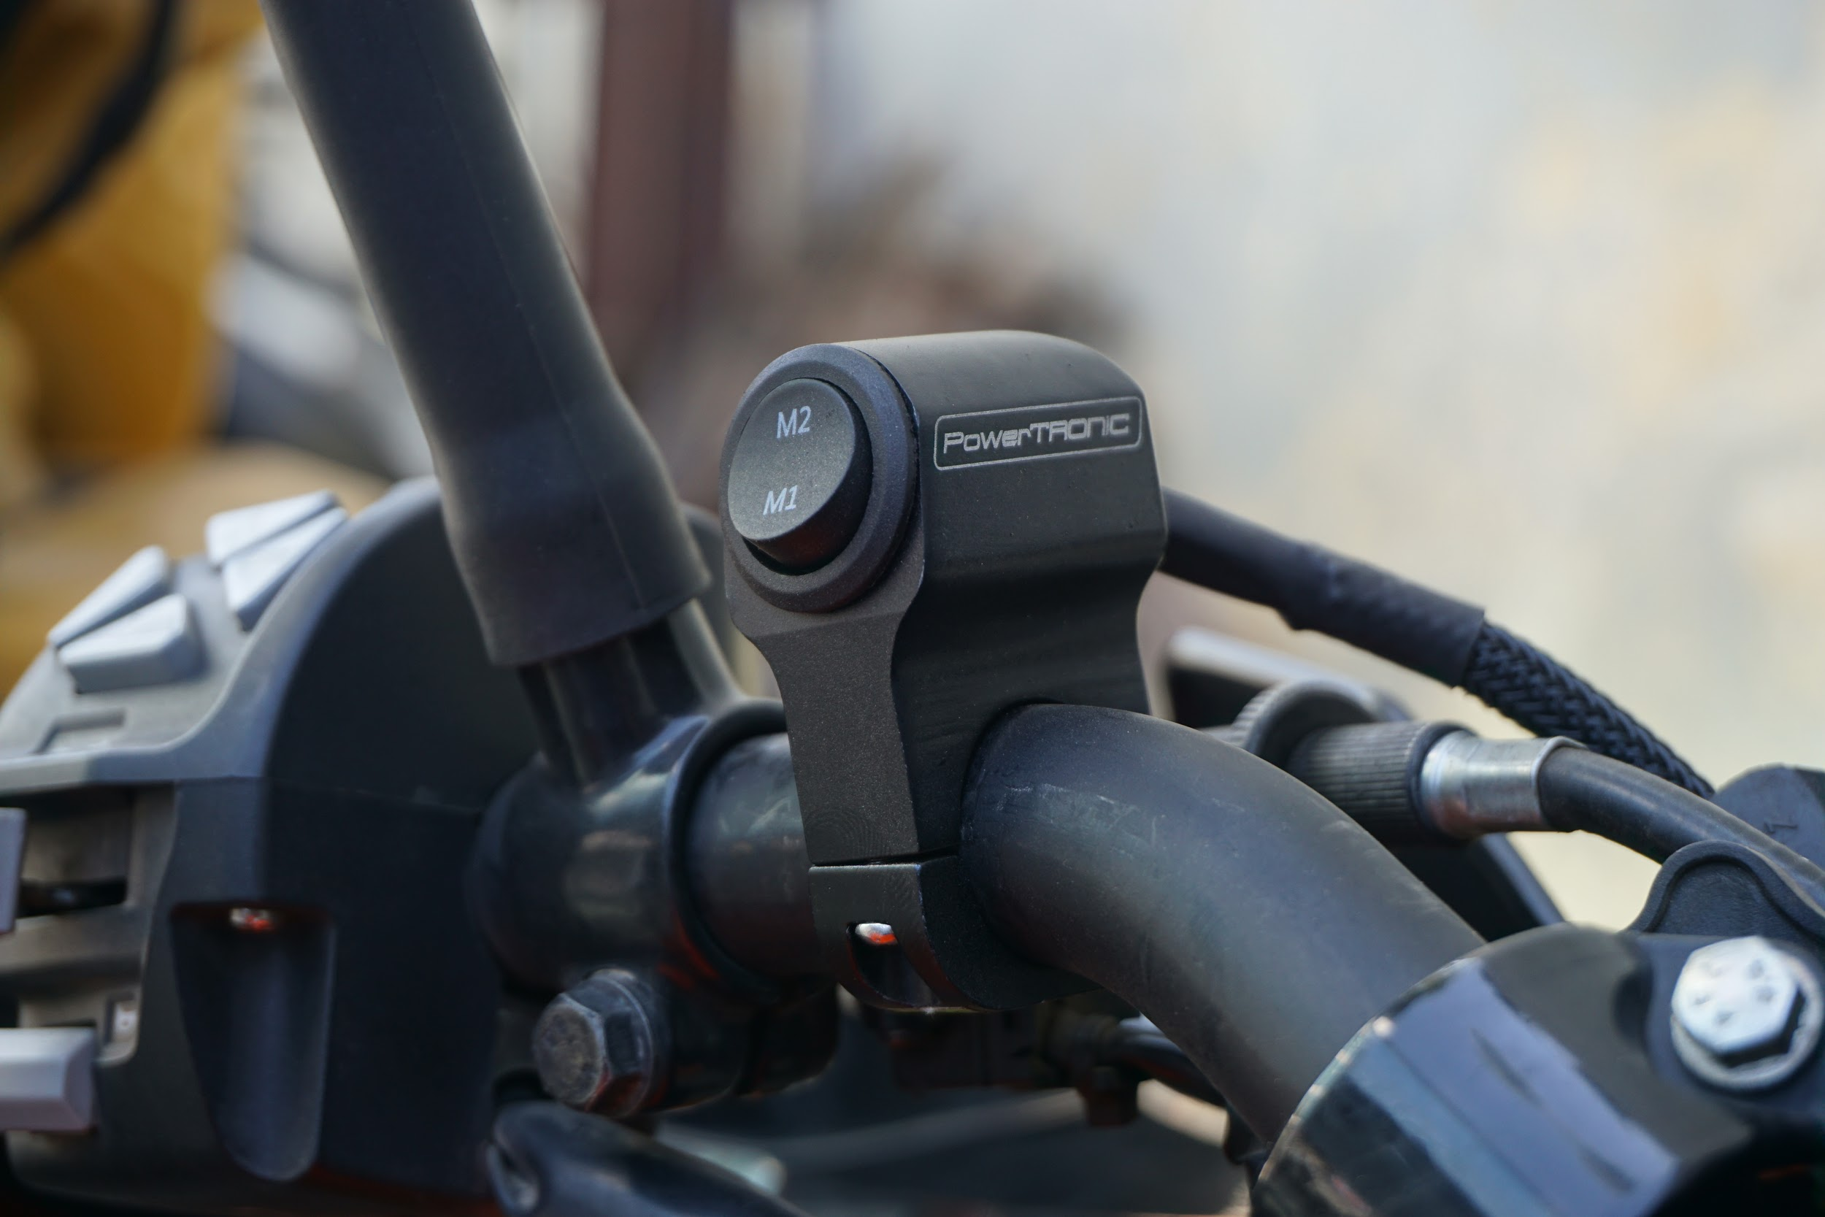

Step 2: Detach the seat and route the map switch wire as shown in the figure. Roll any excess amount of wire under the seat (Refer figure below).
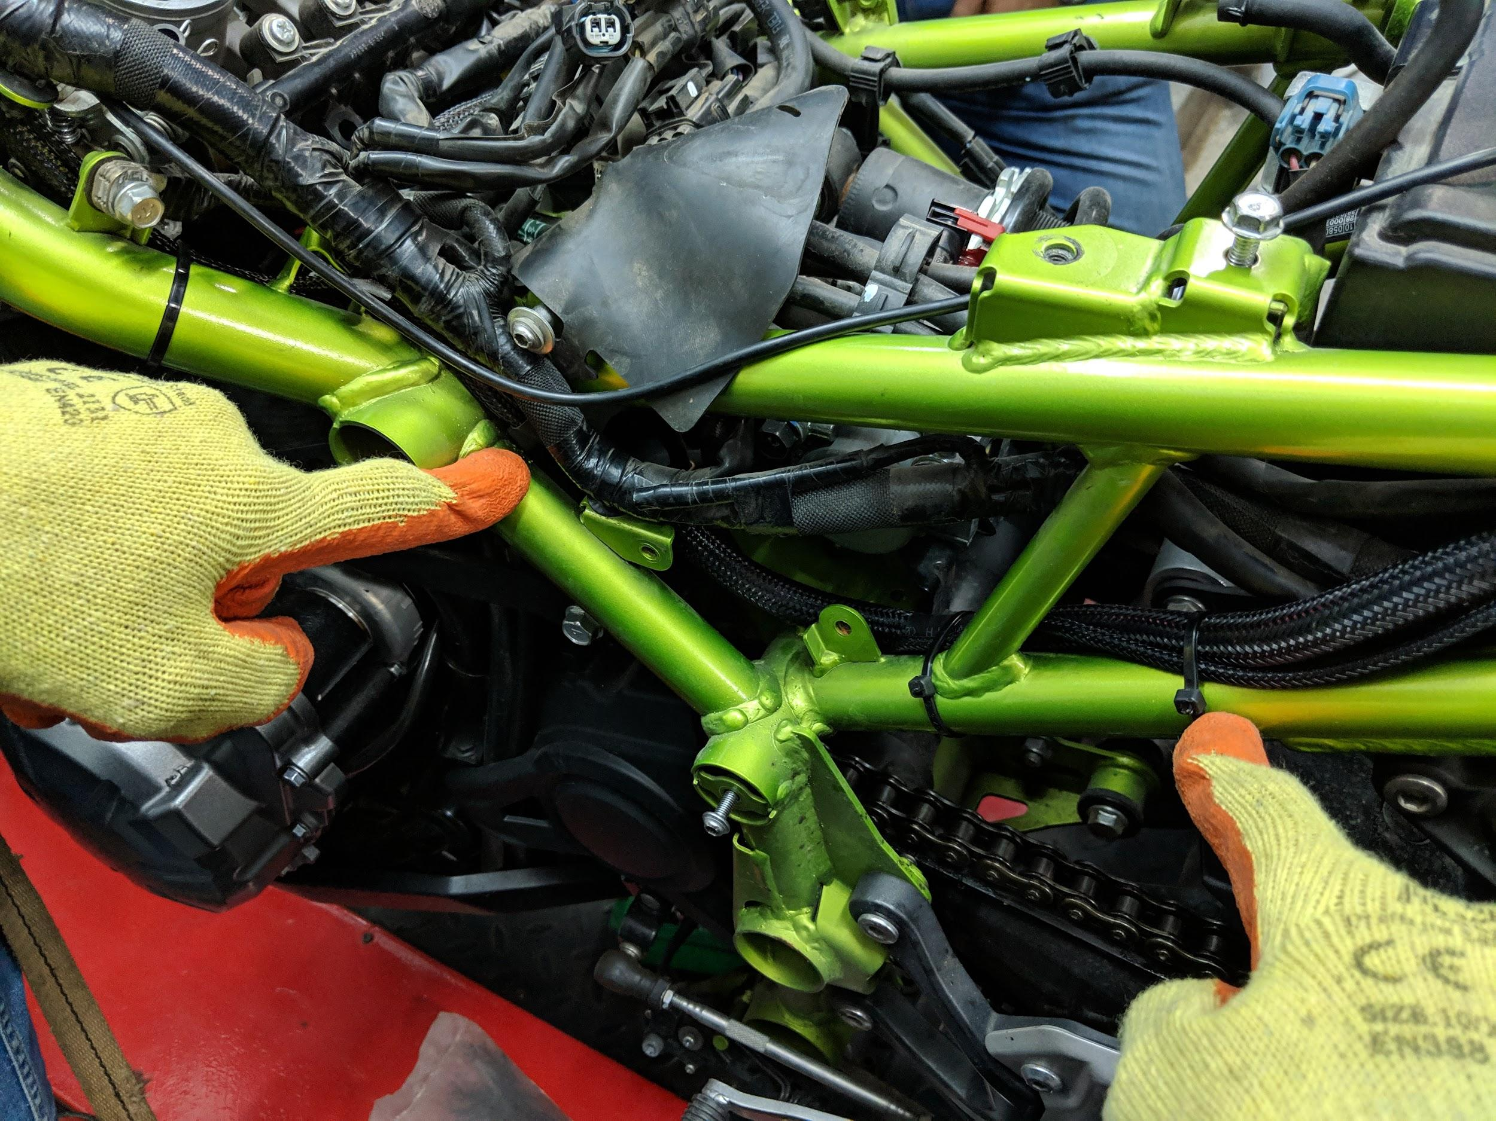

Step 3: Locate the map switch connector male terminal on the PowerTRONIC wiring loom and connect the female terminal of the handlebar switch to this connector. Attach the seat back (Refer Figure below).

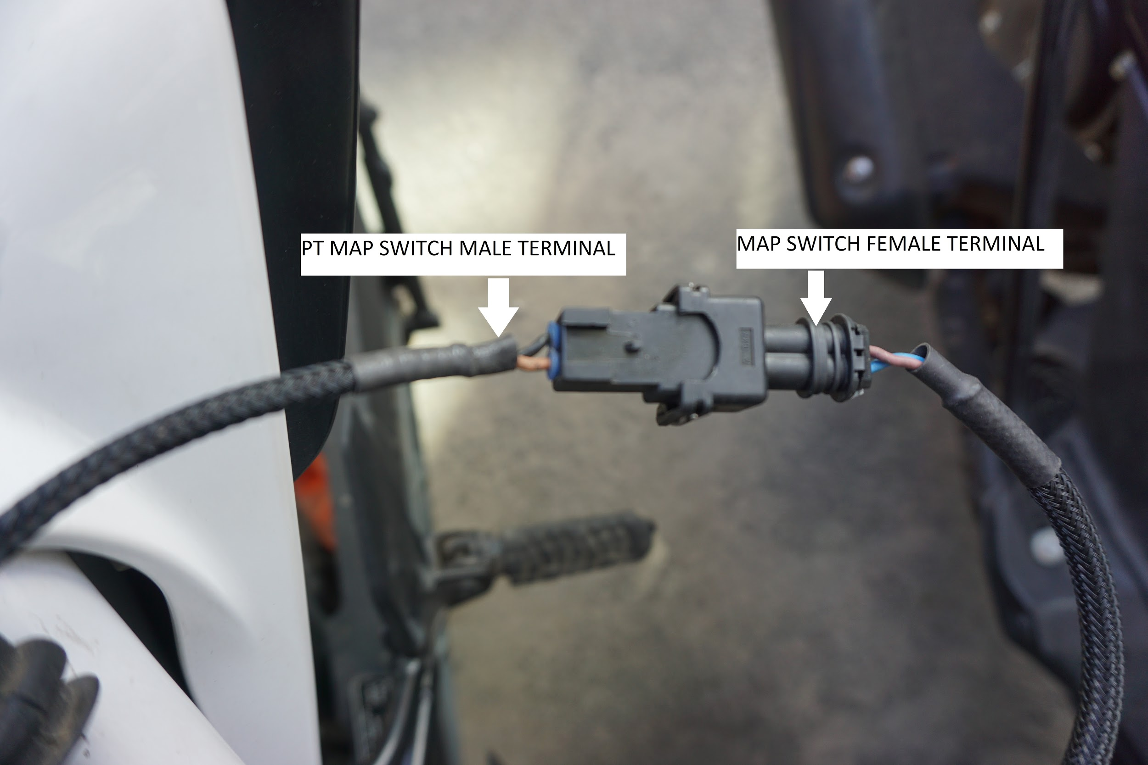
Note: Maps can be changed on the fly. You do not have to turn the engine off to switch between the two on board maps.

---/End of Document/---

