Maps, Switching and Mixing Procedure

Document Version | 1 | Release Date | 05 March 2019

Application information | Generic
Vehicle | Not Applicable
Model | Not Applicable
Year of manufacture | Not Applicable
PowerTRONIC application | All PowerTRONIC ECUs, from firmware version F.3.x onward

Note:

- Read through all instructions before installation and use
- Ensure the bike is switched off and the key is out of the ignition before proceeding with the installation
- Some parts of the bike may be hot and will cause burns. Proceed with caution or wait for the bike to cool down.
- Once the installation is complete, make sure to secure the wiring loom away from the movable parts or components which tend to heat up during the normal operation of the vehicle.
- PowerTRONIC is intended for motorsport use on a closed course, please check with your local laws before using this product. Race Dynamics / PowerTRONIC is not liable for consequences that may arise out of using the product.

Support

Call/Whatsapp: +91 99162 29292 / +91 80409 29292
E-Mail: support@powertronicECU.com
Website: www.powertronicECU.com

Contents

 | Topic | Page
1 | Maps | 3
2 | Switching between maps | 4
3 | Reading a map from the ECU | 5-6
4 | Editing a map on the ECU | 7-8
5 | Downloading a map from the website | 9
6 | Burning a map to the ECU | 10
7 | Map mixing | 11-13

- Maps
A map file or simply a map is the program containing values that determine the ignition, fuel injection and other vehicle-related settings (Traction control, quick shift etc) intended for engine operation.
A PowerTRONIC map file has 3 parts:
- Pre-tuned map 1
- Pre-tuned map 2
- Other settings
The PowerTRONIC ECU can store two pre-tuned maps. Diverse map files depending on your requirement can be downloaded from our website and loaded using the R-Tune software. (Explained later)
A schematic representation of a map file is given below.
$MAPFILE$
Fuel 1+ Ignition 1 =Map 1
(Race mode)

Fuel 2 + Ignition 2 =Map 2 (Race+ mode)

Other Settings
(Includes Traction control, throttle calibration, Quickshifter calibration, and a Configuration tab)

Refer to the R-Tune user interface below. The Active Map (currently map 1) would be displayed on the top of the software user interface.
2. Switching between maps
PowerTRONIC is shipped with two pre-tuned maps. (Map 1- Race mode, Map 2- Race+ mode).
Map 1 or Race mode offers performance gains starting from lower to mid-range RPMs, whereas Map 2 or Race+ mode is a more aggressive map offering performance gains starting from lower to top-range RPMs.
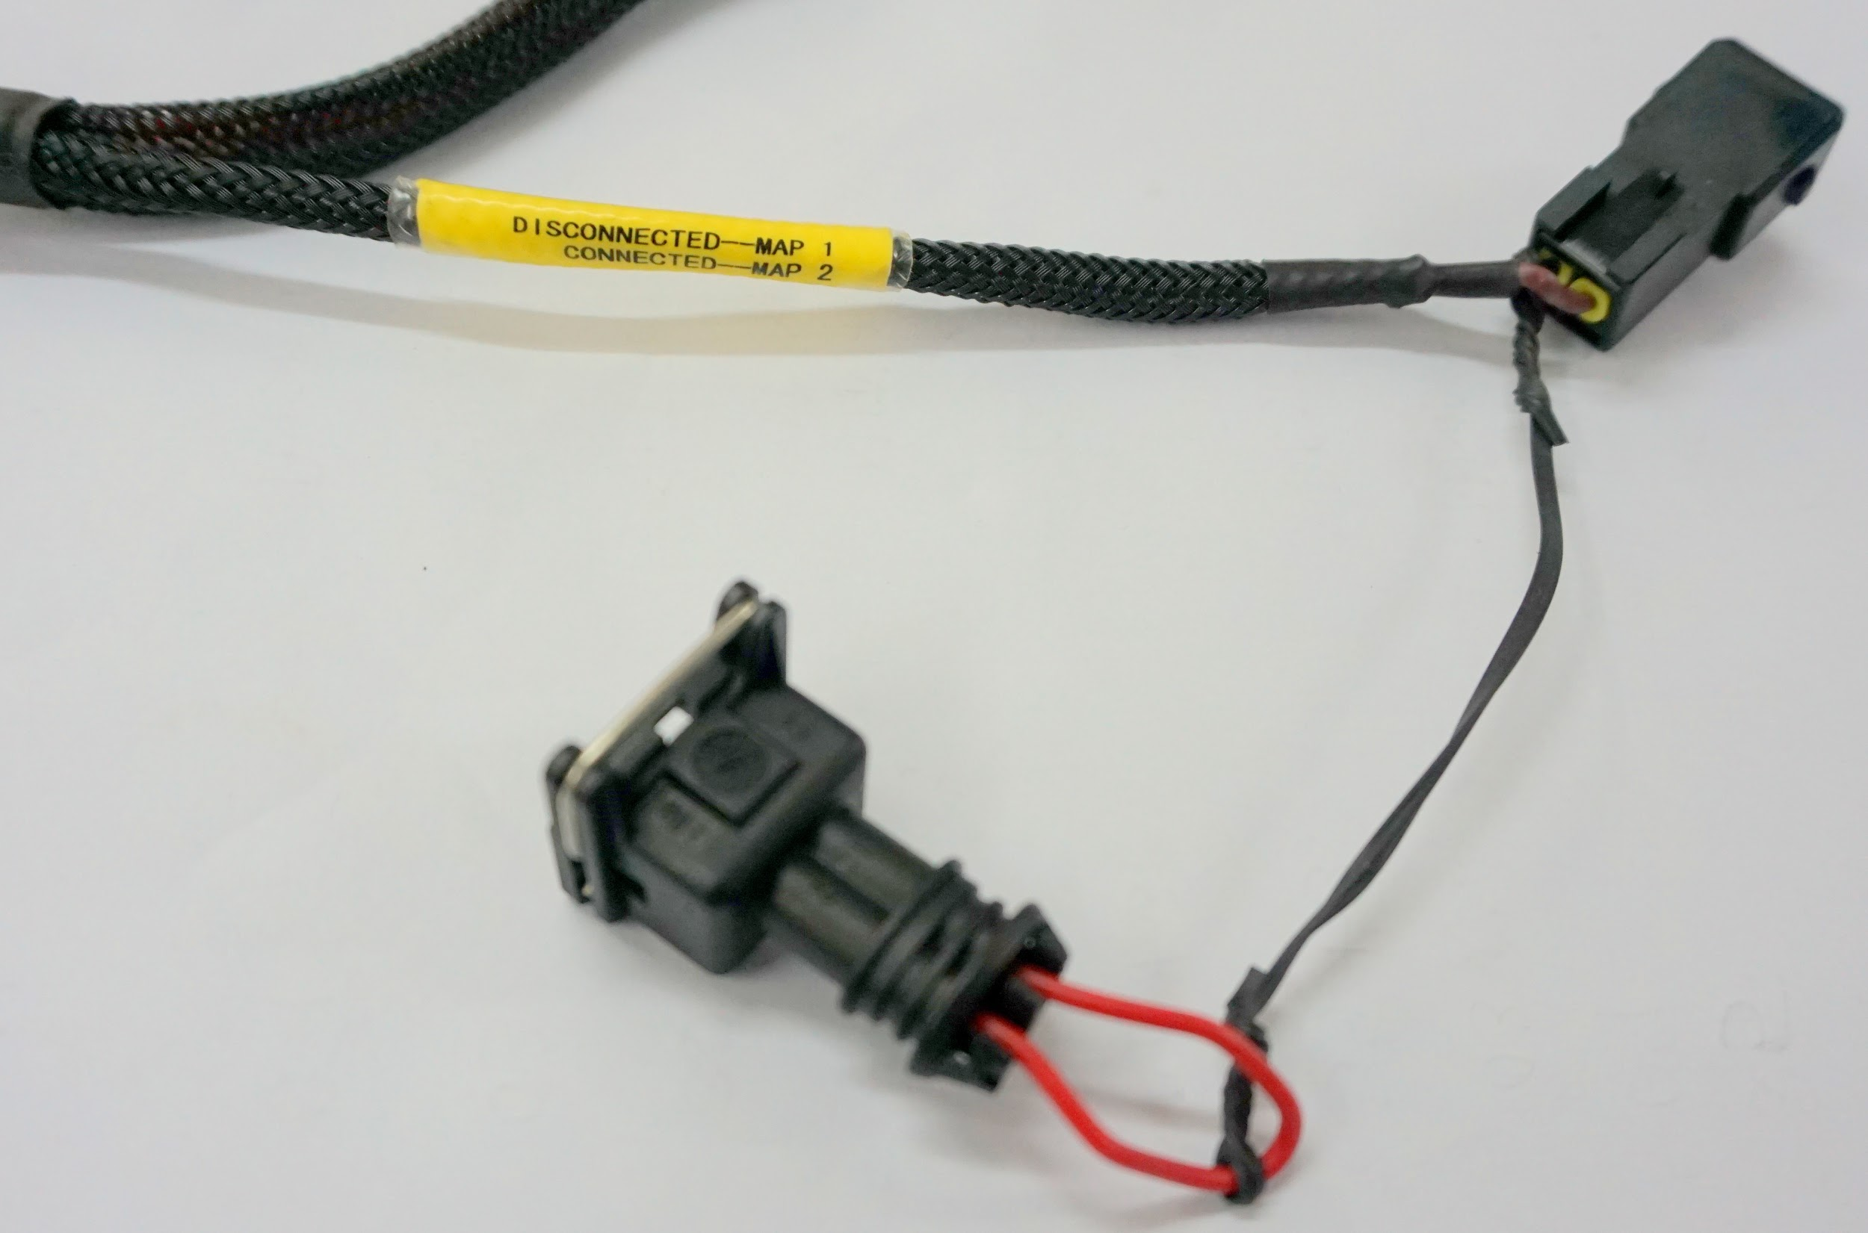
You can switch between the 2 onboard maps by connecting (map 2) or disconnecting (map 1) the map switch connector on the PowerTRONIC wiring harness (Fig A) or by using the handlebar map switch (Fig B) sold separately.
Disconnected - Map1
Connected - Map 2

Fig A
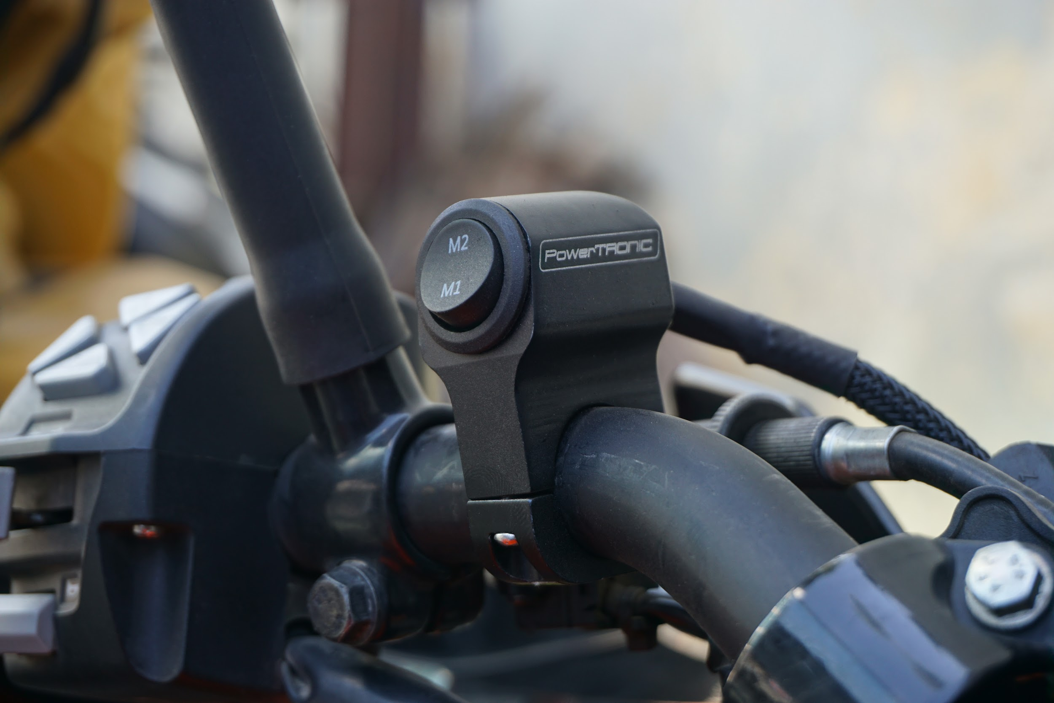
Fig B
To verify which map is currently selected, you can also observe the green LED on the PowerTRONIC ECU.
One Blink = Map 1, Two Blinks = Map 2.

3. Reading the Map from the ECU
To read the map from PowerTRONIC ECU, use the R-Tune software. (Refer the R-tune manual for the R-Tune software)

- Connect PowerTRONIC ECU to the PC using USB data cable provided in the kit.
- Open the R-Tune software.
- Select com port number.
NOTE: (To confirm PowerTRONIC com port number, Right click on My Computer >> Right Click on Properties >> Device Manager >> Double click on Ports (COM & LPT) and note the COM number within the braces on Silicon labs CP210x USB to UART Bridge. Refer to the image below
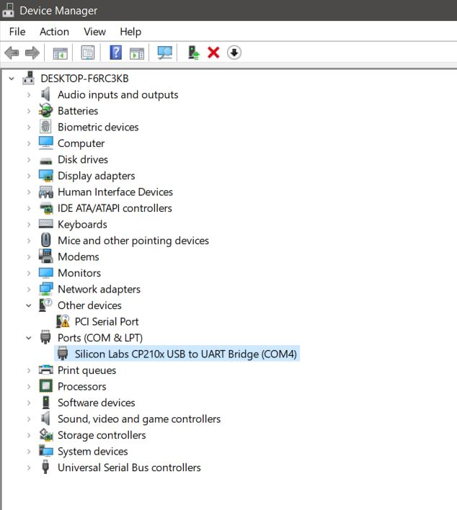

4. On the R-tune software, click on Connect and then Receive. Look for the values of fuel and ignition on a table as below.
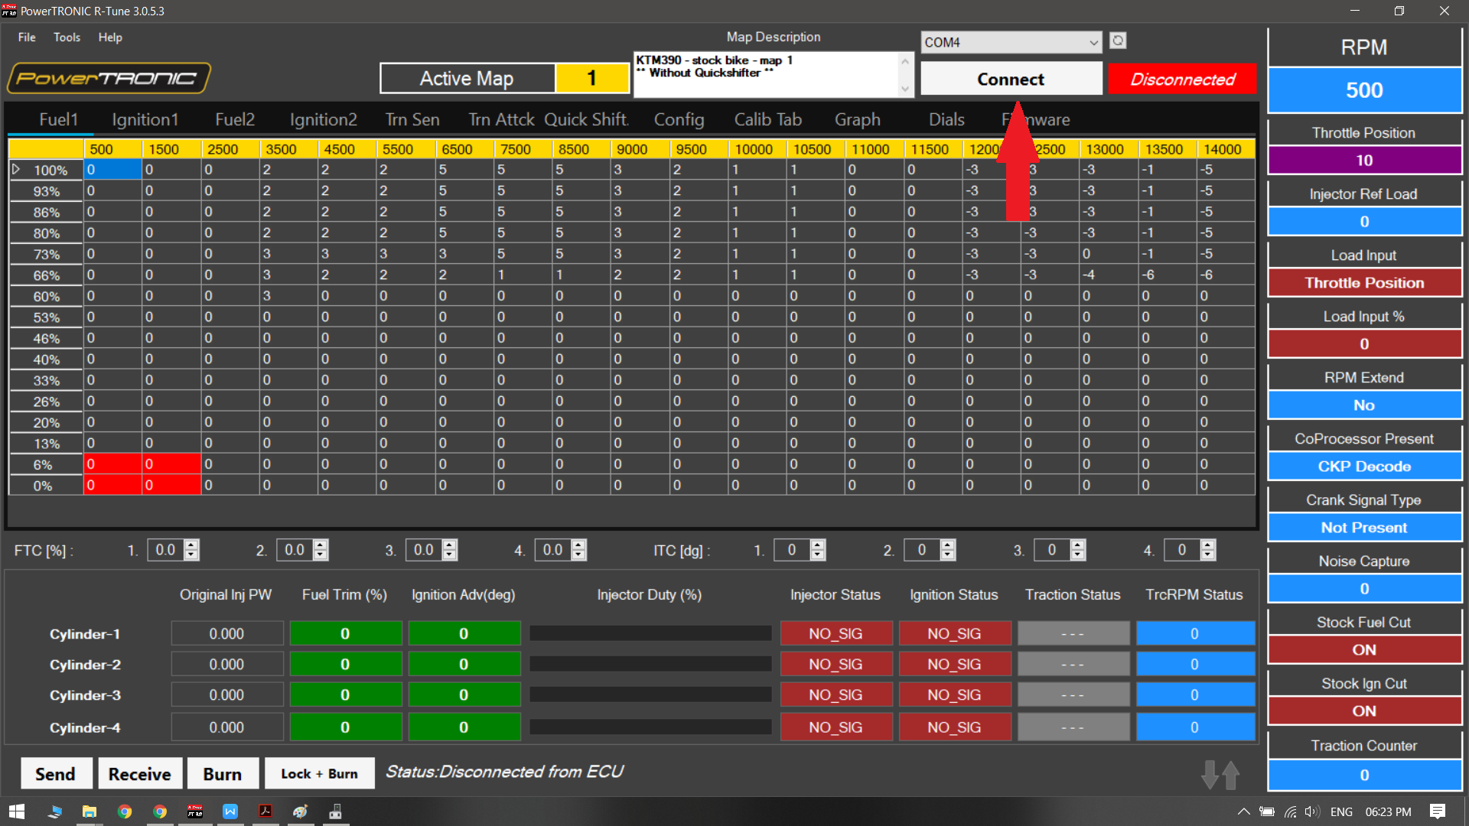
[The Active Map tells you the current map running on the ECU]

4. Editing a Map on the ECU
Warning: An improper or a faulty map value can result in poor performance of the bike and can even cause damages to the engine.
You can edit the maps either by changing the values of the map on the R-Tune interface or by directly downloading a map from our website. A brief description of editing the map is given below. (Refer the detailed manual of R-tune before editing the maps)
- Fuel mapping.
Click on the Fuel tab. (Refer figure below). The table is used to control fuel delivery through map 1 where you can increase or decrease the quantity of fuel delivered to the engine. The fuel tables denote RPM vs Load and spans between min load at the bottom to the maximum load at the top, also minimum RPM on the left and maximum RPM on the right.
The value ‘0’ represents no changes to the fuel injection which is basically the factory settings. Fuel injection is always measured in terms of percentage. The positive value here indicates going richer than stock ECU. In contrast, a negative value indicates going leaner than stock ECU.

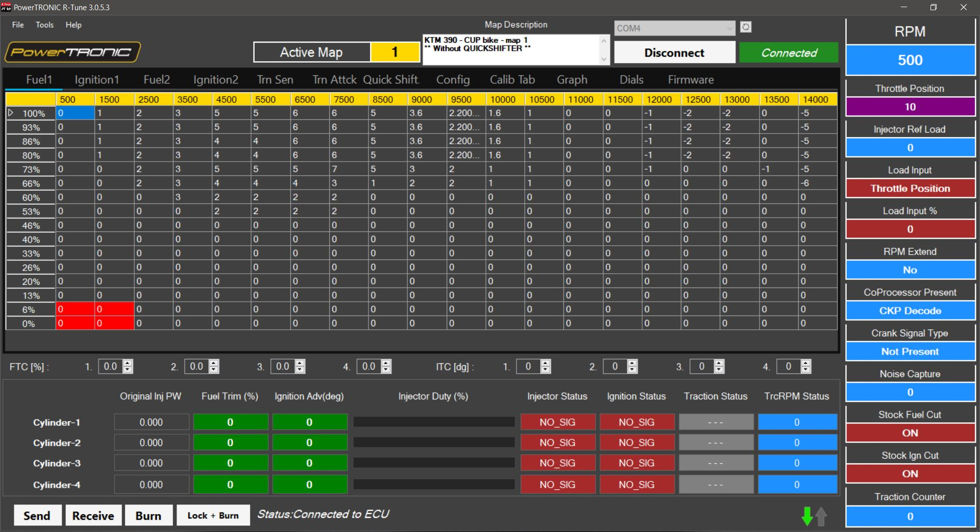

b) Ignition Mapping
Click on the ignition tab. (refer figure below). The table contains the values to control ignition timing. The value ‘0’ represents no changes to the ignition timing/spark which is basically the factory settings. Ignition timing/spark is always measured in terms of degrees. The positive value here indicates advancing the ignition timing than stock ECU. In contrast, a negative value indicates retarding the ignition timing than stock ECU.

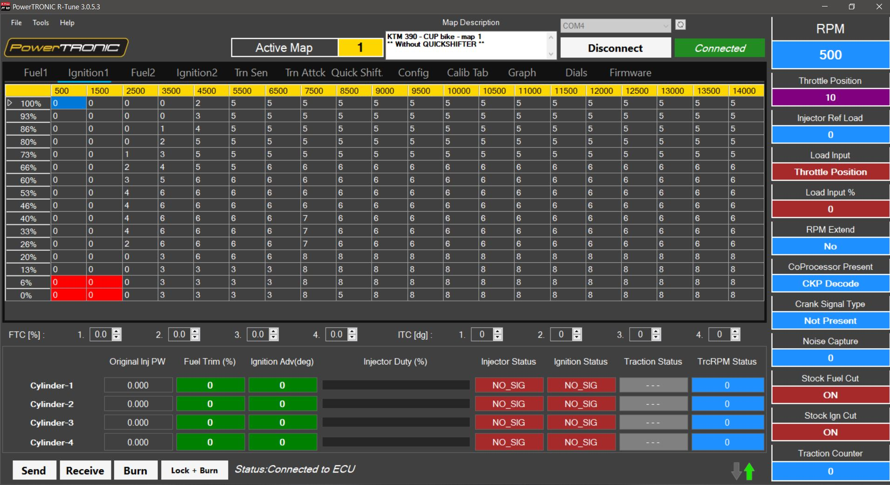

5. Downloading a map from the website
- Go to http://powertronic.racedynamics.com/
- To select a bike specific map file, navigate to bike specific page by moving the cursor to CHOOSE YOUR BIKE. 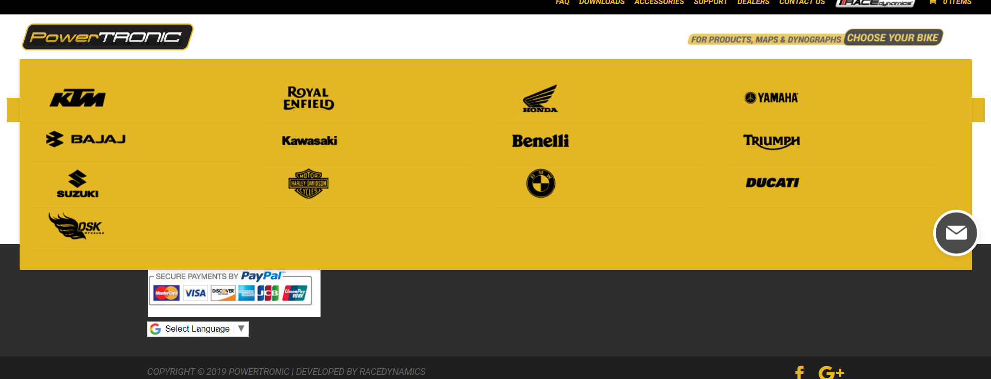

- Select your bike model, Click on MAPS and then click DOWNLOAD HERE (refer the figure below).
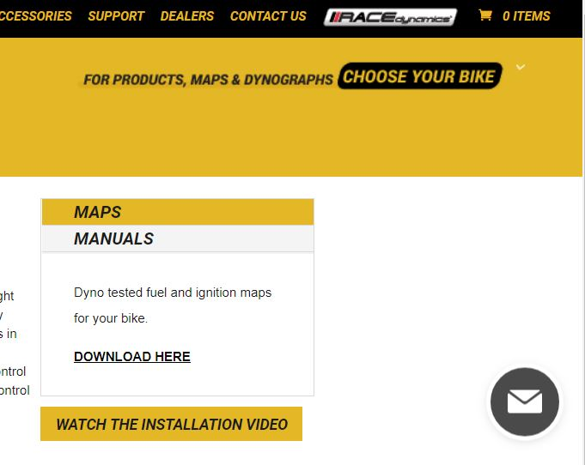

6. Burning a map to ECU
To load a new map file:
- Connect the PowerTRONIC ECU to your Windows PC using the USB cable.
- Open the R-Tune software.
- Select the appropriate COM port number.
- Click on Connect.
- Click on File then Open (Refer the figure below)

6. Select the downloaded map file from the file manager.
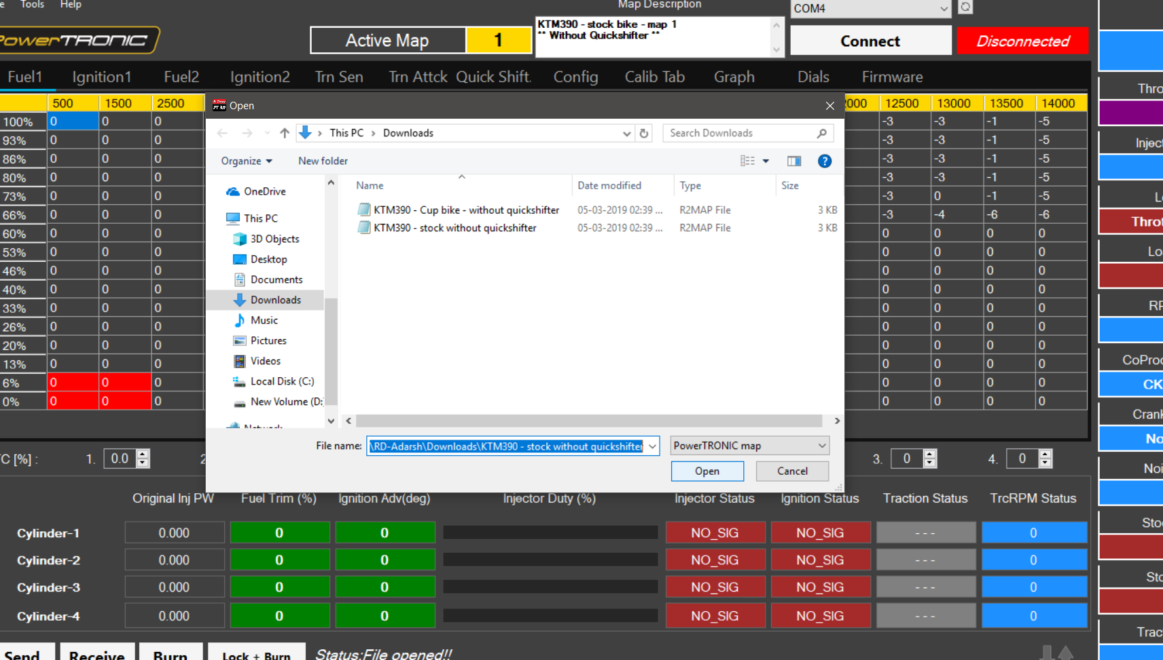
7. Click Open.
8. Click on Send and then Burn. [Make sure the bike is off before clicking Burn]

7. Map Mixing
You can develop a custom map file using the R-Tune software by combining the modes from different maps based on your requirements. (Refer schematics given below)

- Open the R-Tune Software.
- Click on Connect and then Receive
- Go to File, Select Open Multiple Files
- The Map Mixer dialog box with four individual file settings will open.
Note: ‘Use Current Data’ section contains the 2 maps that are pre-loaded to the ECU.
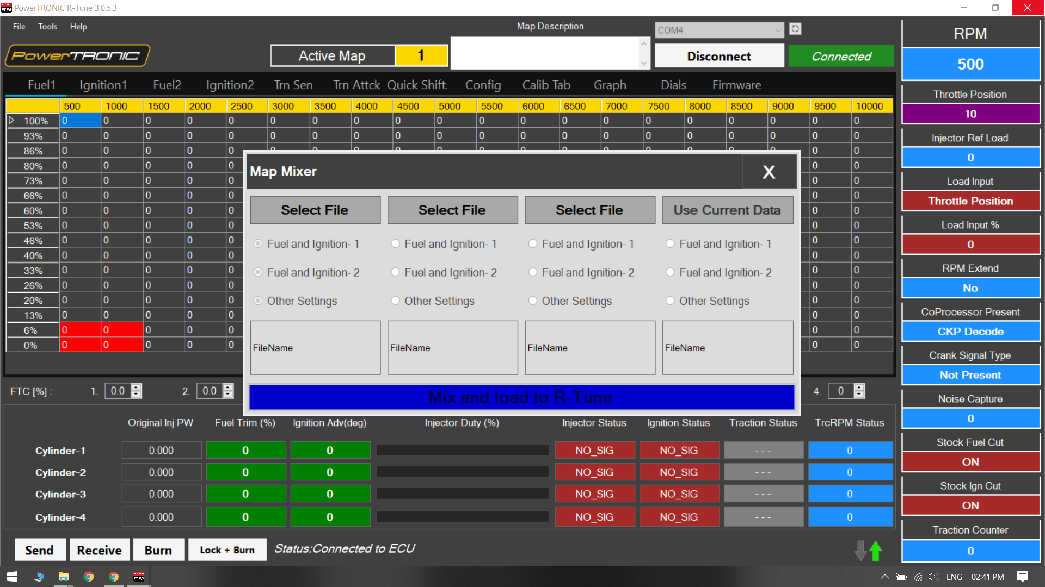

- Click on Select File option and select the map stored on your PC. (You can choose multiple maps for the 3 sections except for Use Current Data section). You can select any map by clicking on the Fuel and Ignition -1/ Fuel and Ignition -2 depends on your preference.
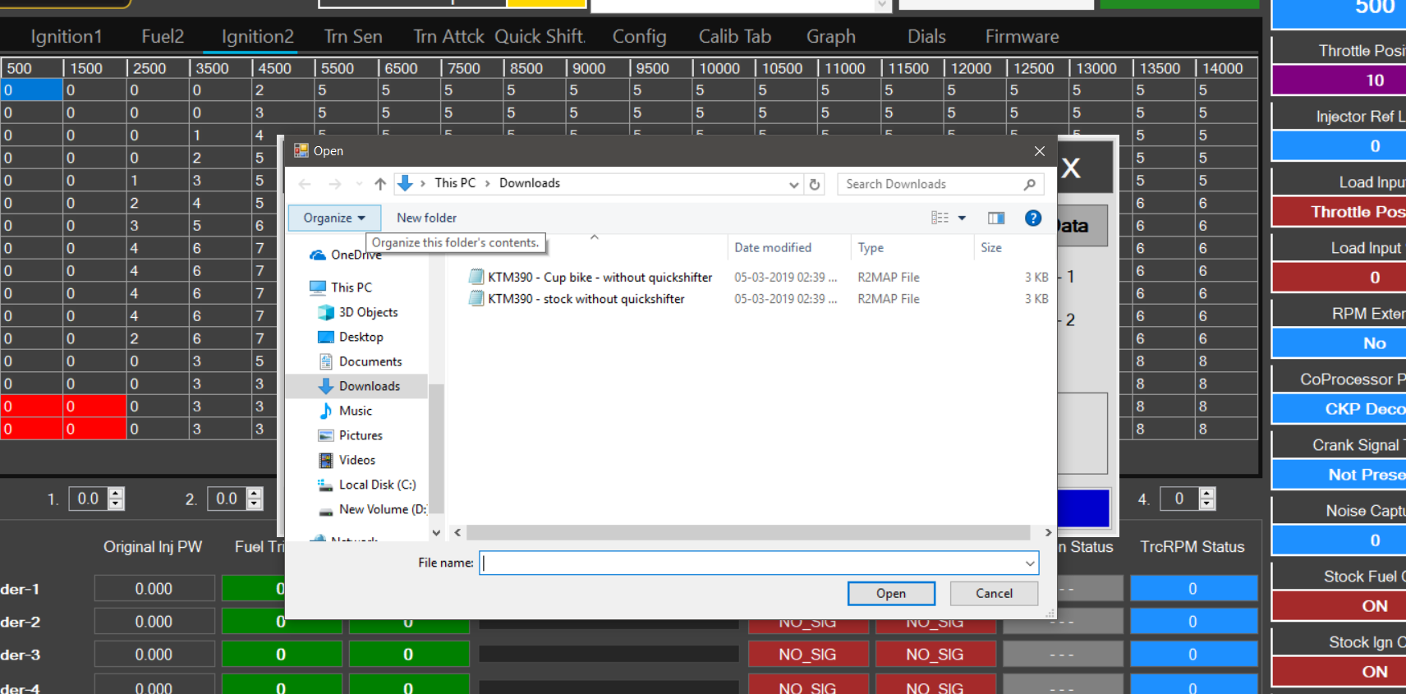
- If you would like to choose between one of map that is preloaded on the ECU and one map of your choice, you can decide from the dialog box shown below
Note: Other settings contains data from other tabs of R-Tune. Ex: Config, Quick-Shifter, Traction Sensitivity, and Traction Attack.
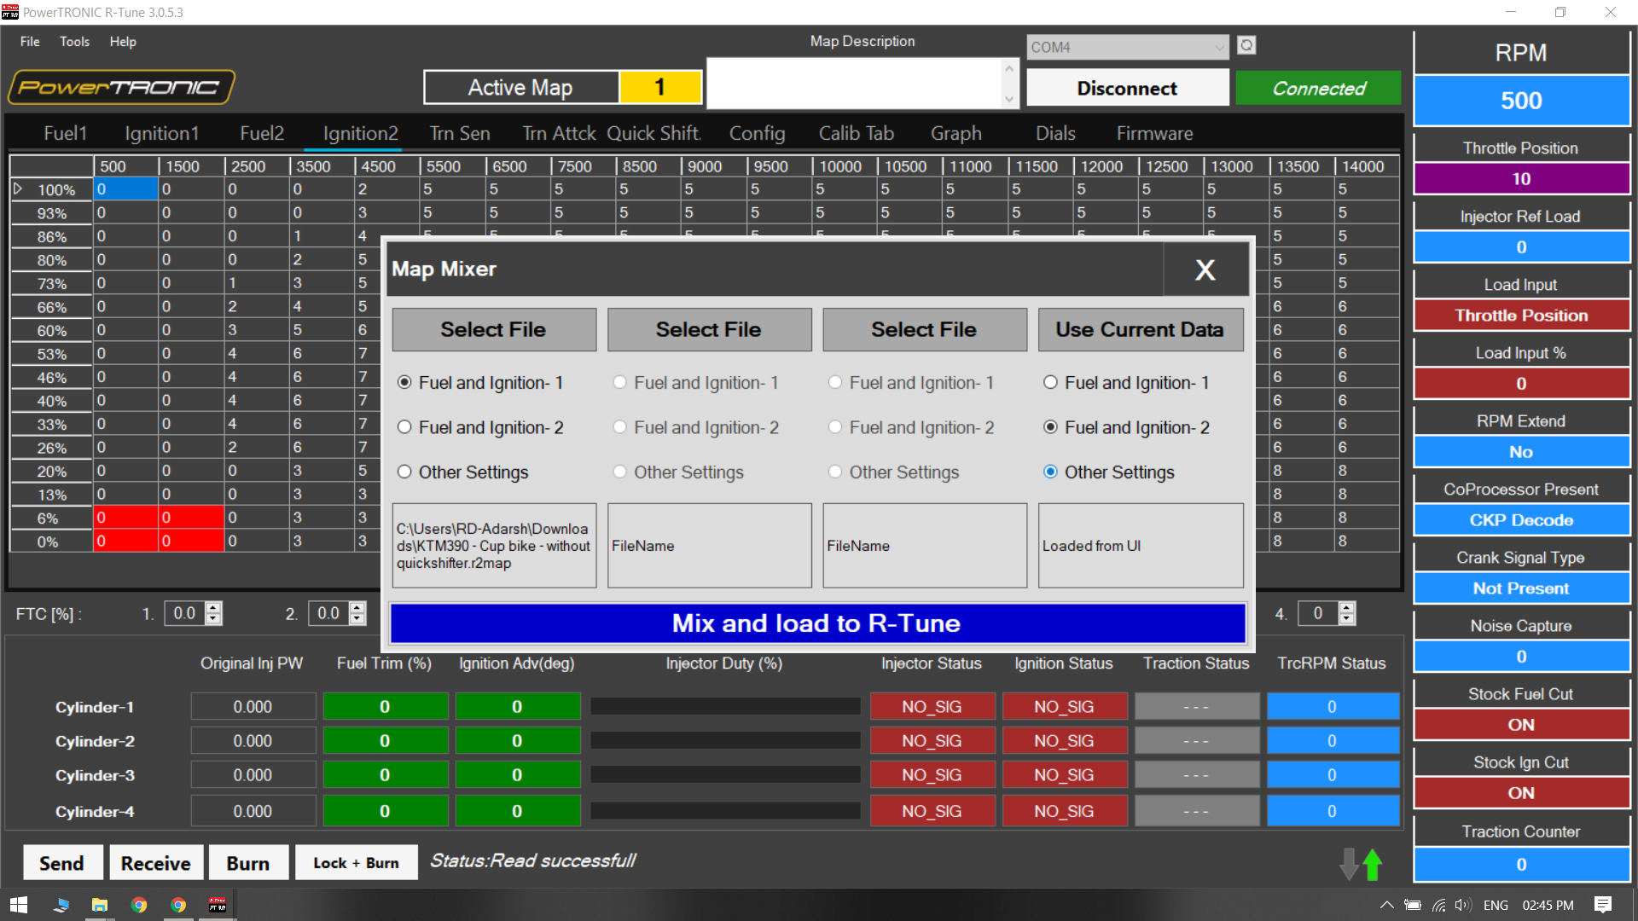
- Click on Mix and load to R-Tune.
- Click on Send and then Burn. [Make sure the bike is off before clicking Burn]

---/End of Document/---

