R-Tune Installation and Connecting to ECU

Document Version | 1 | Release Date | 05 March 2019

Application information | Generic
Vehicle | Not Applicable
Model | Not Applicable
Year of manufacture | Not Applicable
PowerTRONIC application | All PowerTRONIC ECUs, from firmware version F.3.x onward

Note:

- Read through all instructions before installation and use.
- Ensure that the bike is switched off and the key is out of the ignition before proceeding with the installation.
- Some parts of the bikes might be hot/sharp and may cause burns/cuts. Proceed with extreme caution or wait until the bike has cooled down. Always wear safety gloves.
- When the installation is complete, make sure to secure the wiring loom away from the movable parts or components which tends to heat up during the normal operation of the vehicle at any chance.
- PowerTRONIC is intended for motorsport use on a closed course, please check with your local laws before using this product. Race Dynamics / PowerTRONIC is not liable for consequences arising out of using the product.

Support

Call/Whatsapp: +91 99162 29292 / +91 80409 29292
E-Mail: support@powertronicECU.com
Website: www.powertronicECU.com

The PowerTRONIC is an open user tuneable piggyback ECU. You can either use the provided maps, download maps from our website or create your own maps using the R-Tune tuning software. 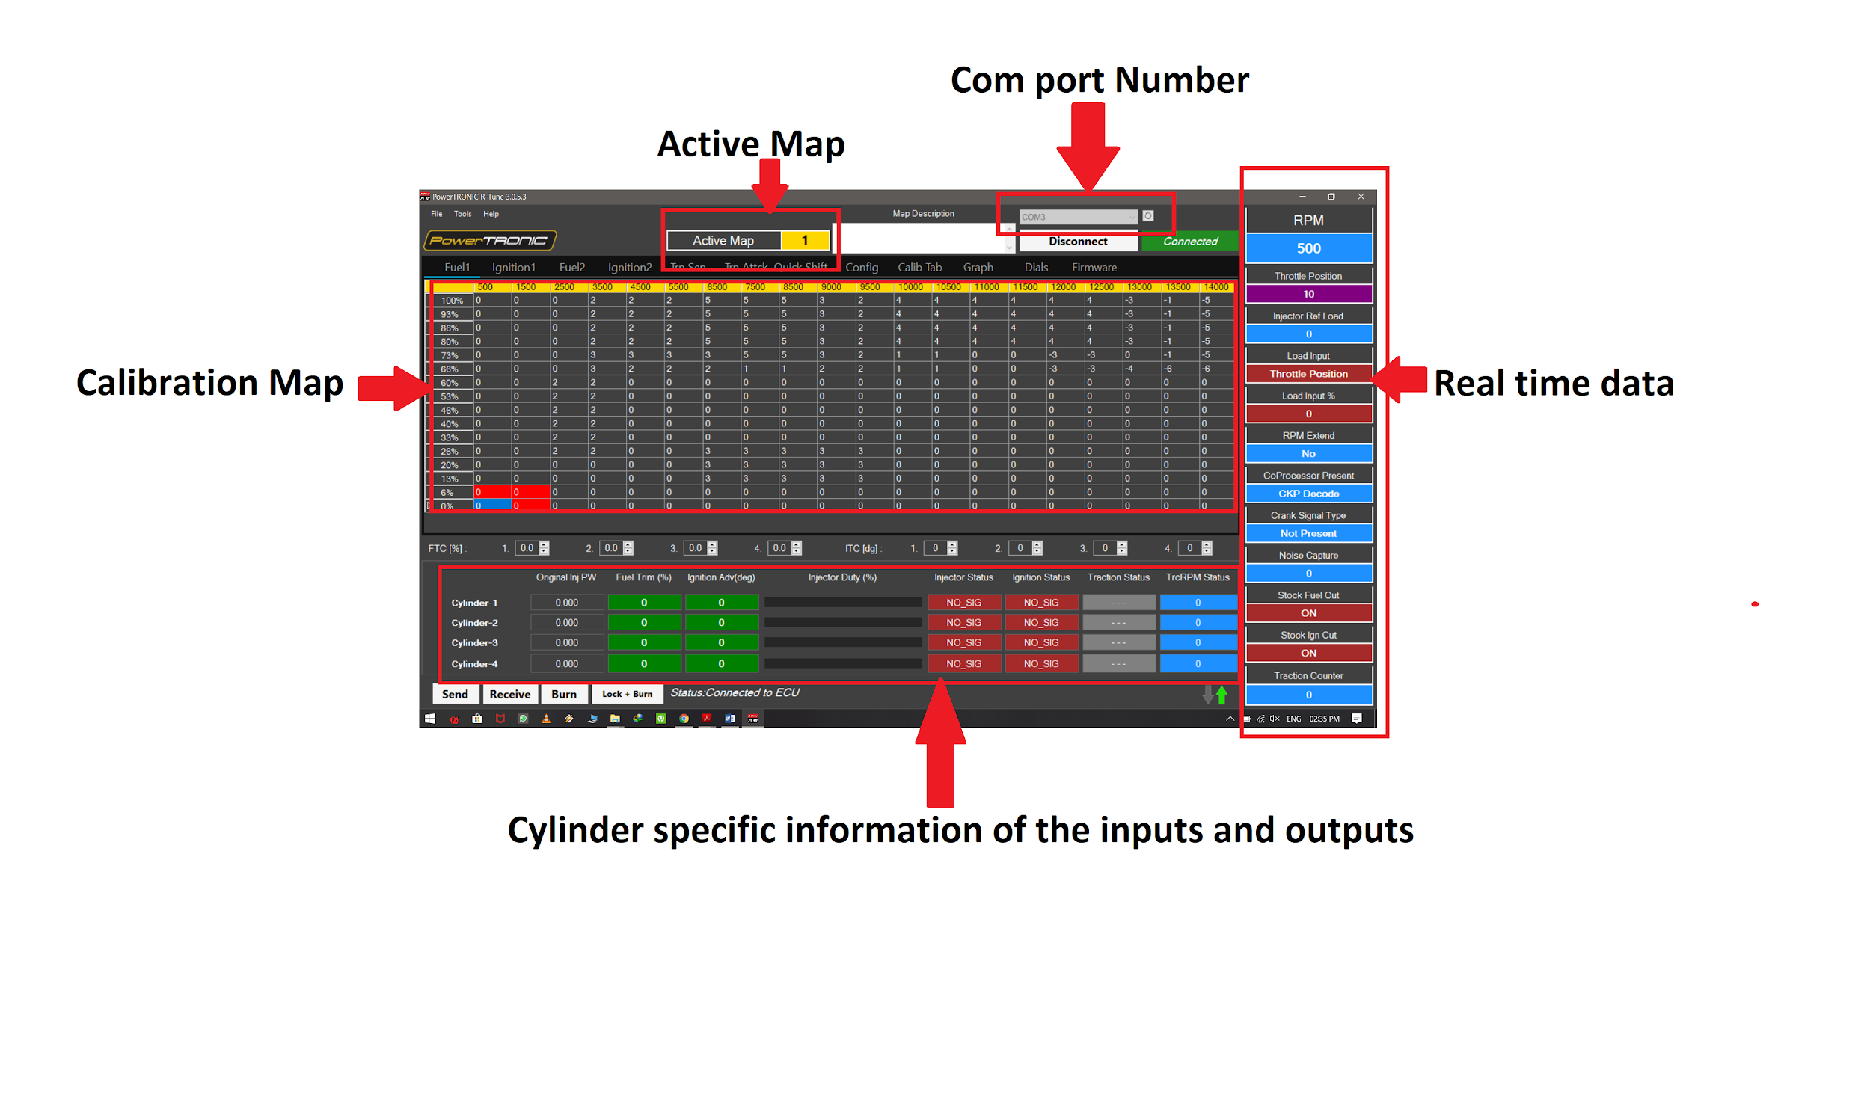
R-Tune user interface
Requirements
- Minimum Recommended system configuration OPERATING SYSTEM WINDOWS 7/8/10
- RAM 512 MB (minimum)
- USB Type A port
- Stable internet connection
- Any file extracting software preinstalled (ex Winrar, Winzip, 7Zip)

General information:
- Uninstall any previous versions of R-Tune before proceeding.
- Microsoft .NET framework must be installed on the PC without which R-Tune cannot be installed.
- PowerTRONIC is a USB powered device, so it does not need to be connected to a vehicle or specifically turned on to establish communication with the computer.
- The setup automatically places a shortcut to R-TUNE on your desktop.
- Refer R-Tune ‘Tuning Manual’ for more details.

R-Tune Installation

To download and install R-Tune software, follow the instructions

- Go to www.powertronicECU.com and select the Downloads option.
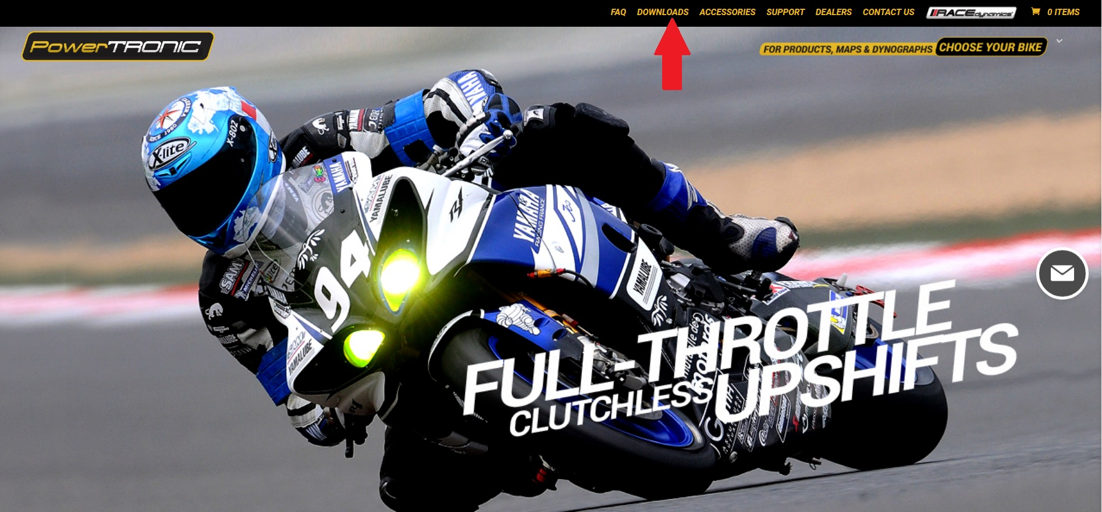

- Choose R-TunePT from the menu.
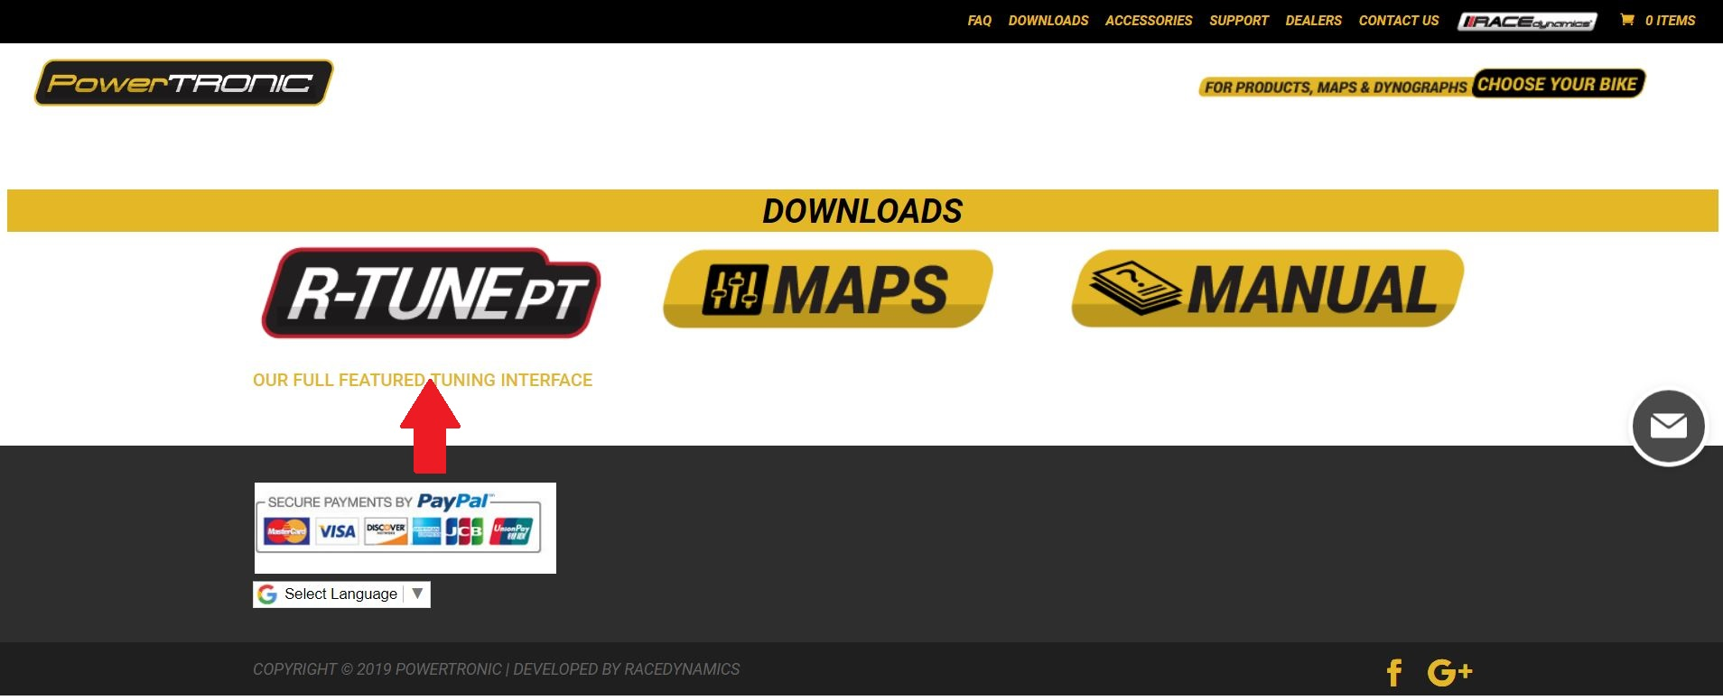

- Locate the serial number on your PowerTRONIC ECU and compare it with to versions and identify the appropriate R-Tune software for your ECU (refer figure below).
Select the specific software set up and click Download.
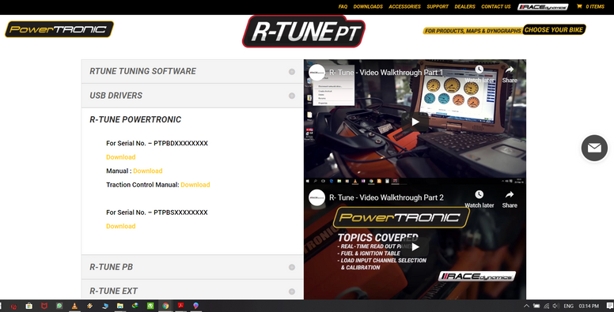
3.1 Open/Extract (using winzip/winrar/7zip etc) the setup.zip file and run setup.exe.
3.2 To install the software, double click on the set up downloaded.
3.3 Follow the installation wizard to complete the installation process.

4. Downloading the USB Drivers.

4.1 To download the USB drivers, select USB DRIVERS and click on the link to download. (refer figure below) Right click on the file, and then choose Extract files.
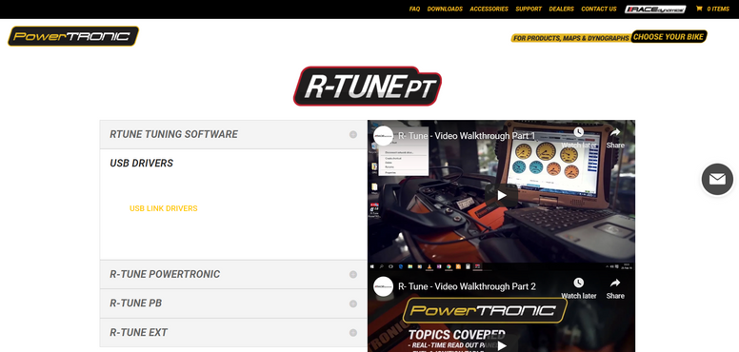

4.2 To install drivers, double click CP210xVCPInstaller_x64 (for 64bit system) or CP210xVCPInstaller_x86 (32bit system) depend on your system configuration. Refer figure below. Follow the instructions by Driver Installer Wizard

Note: To check whether your computer is 32 or 64 bit, right click on My Computer and click on Properties and check System type.(Refer image below)

Connecting R-Tune to ECU

5. Open the R-Tune software by double clicking the icon on the desktop of the PC.

6. With the PowerTRONIC connected to your bike, use the USB cable and connect it to the PC

7. Identify the correct COM Port in Device Manager and locate the same COM Port in the RTune software before clicking on Connect. Refresh the list if necessary by clicking the Refresh button [🔄]. Refer Figure below

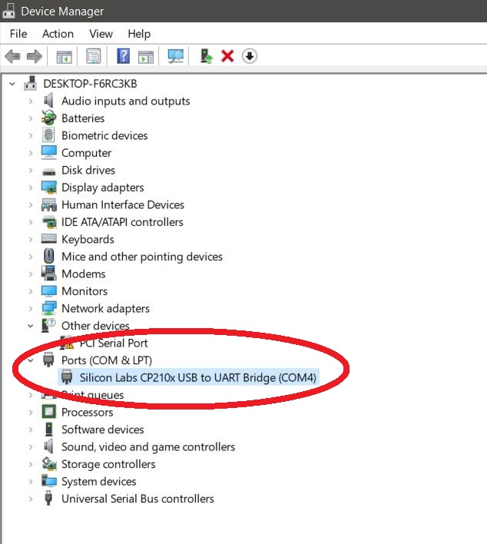
(To check your com port number, go to Device Manager, Select Ports (COM & LPT) and note the number on the Silicon labs CP210x USB to UART Bridge. Refer figure below)
8. Once the appropriate COM Port number is selected, Click on Connect.
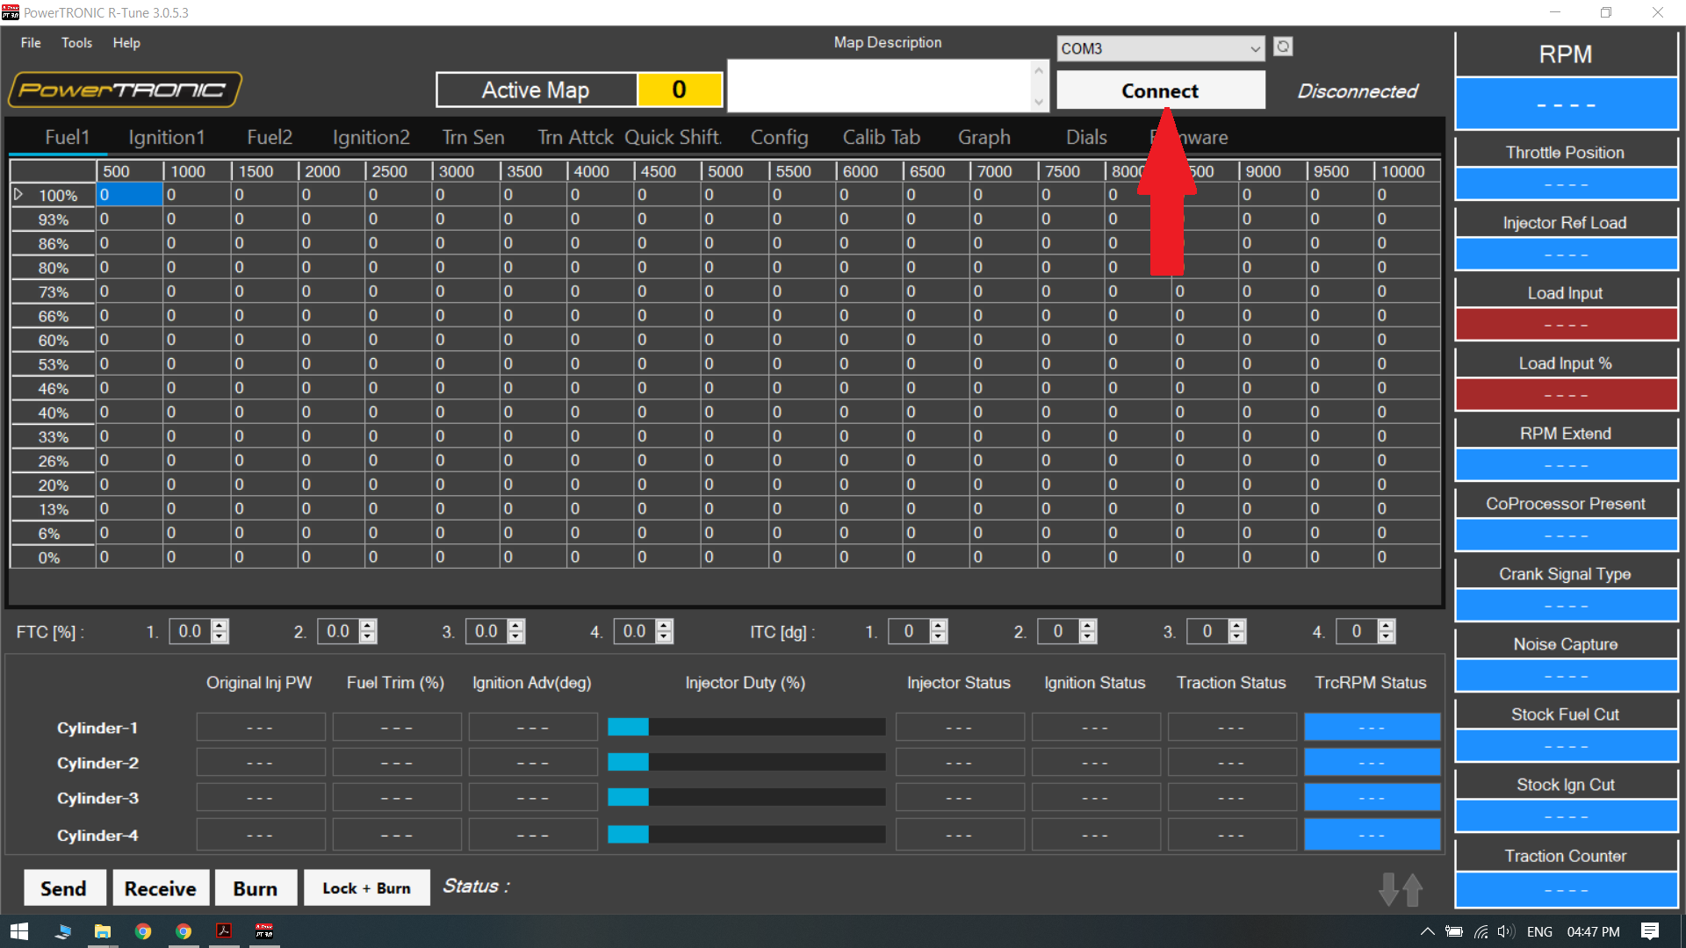

9. Click on Receive to read the data.

---/End of Document/---

