Stock Coupler Test

Document Version | 1 | Release Date | 05 March 2019

Application information | Generic
Vehicle | Not Applicable
Model | Not Applicable
Year of manufacture | Not Applicable
PowerTRONIC application | All PowerTRONIC ECUs, from firmware version F.3.x onward

Note:

- Read through all instructions before installation and use.
- Ensure that the bike is switched off and the key is out of the ignition before proceeding with the installation.
- Some parts of the bikes might be hot/sharp and may cause burns/cuts. Proceed with extreme caution or wait until the bike has cooled down. Always wear safety gloves.
- When the installation is complete, make sure to secure the wiring loom away from the movable parts or components which tends to heat up during the normal operation of the vehicle at any chance.
- PowerTRONIC is intended for motorsport use on a closed course, please check with your local laws before using this product. Race Dynamics / PowerTRONIC is not liable for consequences arising out of using the product.

Support

Call/Whatsapp: +91 99162 29292 / +91 80409 29292
E-Mail: support@powertronicECU.com
Website: www.powertronicECU.com

The stock coupler can be used for the following:
- To revert your bike to factory settings without the need to remove the PowerTRONIC harness.
- To verify if the connections are correct before proceeding to use PowerTRONIC ECU.

It has individual LEDs to indicate the status of each connection.
- INJ PWR - Green - represent injector power supply.
- SPK PWR - Green - represent ignition coil power supply.
- CKP - red -to indicate Crankshaft Position Sensor.
- TPS - red - to indicate Throttle Position Sensor.
- INJ & SPK (4 nos) -red - indicate the injector and spark plug connections for each cylinders (up to four cylinders)

After the completion of installing the PowerTRONIC harness, you can verify the connections are made properly by connecting the stock coupler. Refer the schematic and chart to understand the working principle of stock coupler.
.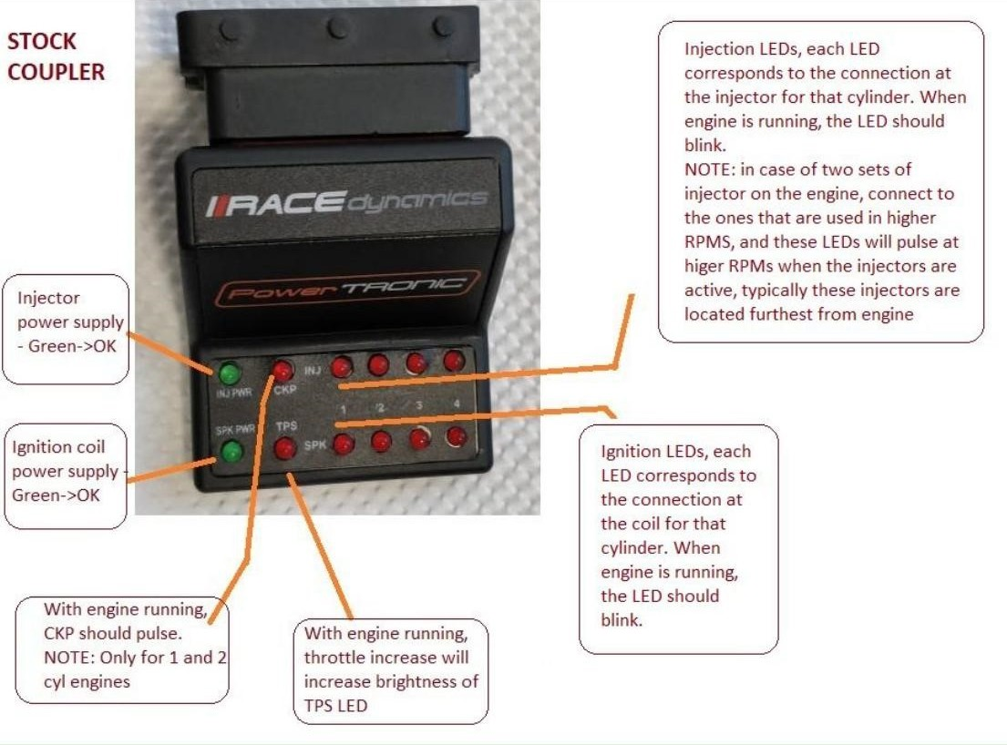

Vehicle to be started, and idling or lower rpm condition
LED / lamp on stock coupler | Condition of acceptance
INJ_PWR | Should be ON
SPK_PWR | Should be ON
TPS (throttle position sensor) | Increases brightness with increase in throttle  NOTE: in some cases, this lamp may not be visible, in such conditions connect the R-tune software and verify that TPS is working
INJ LED (1, 2, 3, 4) | Blinking, corresponds to number of cylinders connected to.  Example, on a single cylinder bike, only INJ 1 LED will blink
SPK LED (1,2,3,4) | Blinking, corresponds to number of cylinders connected to.  Example, on a single cylinder bike, only SPK 1 LED will blink
CKP (crankshaft position sensor) | Blinks with engine running, may not be bright enough on certain  vehicles in lower pms

If all the aforementioned conditions are met, you can confirm that the connections are done properly.
If not check the respective connections.

---/End of Document/---

