Upgrading the Firmware

Document Version | 1.1 | Release Date | 05 March 2019

Application information | Generic
Vehicle | Not Applicable
Model | Not Applicable
Year of manufacture | Not Applicable
PowerTRONIC application | All PowerTRONIC ECUs, from firmware version F.3.x onward

Note:

- Read through all instructions before installation and use.
- Ensure that the bike is switched off and the key is out of the ignition before proceeding with the installation.
- Some parts of the bikes might be hot/sharp and may cause burns/cuts. Proceed with extreme caution or wait until the bike has cooled down. Always wear safety gloves.
- When the installation is complete, make sure to secure the wiring loom away from the movable parts or components which tends to heat up during the normal operation of the vehicle at any chance.
- PowerTRONIC is intended for motorsport use on a closed course, please check with your local laws before using this product. Race Dynamics / PowerTRONIC is not liable for consequences arising out of using the product.

Support

Call/Whatsapp: +91 99162 29292 / +91 80409 29292
E-Mail: support@powertronicECU.com
Website: www.powertronicECU.com

REQUIREMENTS:

1) Windows PC with Genuine Windows Operating System (7/8/10) and have R-Tune software installed. (Refer R-Tune installation document)
2) The new version of firmware file in the file manager.
3) Uninterrupted power supply.
4) USB Cable provided within the kit.

WARNING:

1) Disconnect the ECU from the vehicle before upgrading firmware.
2) The upgrade process after selecting the firmware file is automated. If the ECU is upgradeable/compatible with the new firmware version file, it will automatically start the process. If the ECU is not compatible with the new firmware version file, it will ask you to check for the correct upgrade version. At this point, you can cancel the process.
3) DO NOT touch/move the ECU once the upgrade process is started.
4) DO NOT click/turn off on the computer once the upgrade process is started.
5) DO NOT remove the USB cable once the upgrade process is started.

- Connect PowerTRONIC ECU to the R-Tune software using the BAFO cable provided.
a) Select appropriate com port number
b) Click on Connect
c) Go to the Firmware tab (Refer the image)
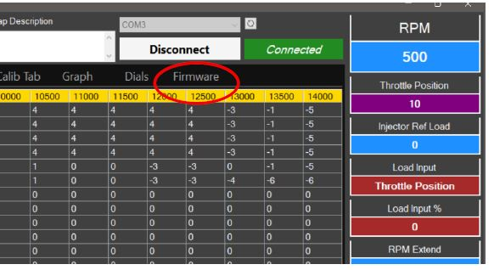

2. Click Upgrade Firmware option
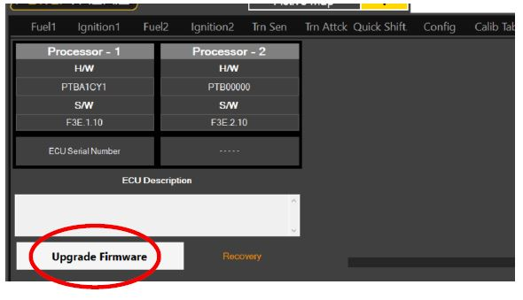

3.Read through the instructions displayed and click OK.
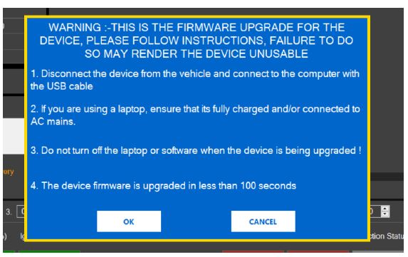

4. Click Okay.

5. Select the firmware file from the file manager and click Open.

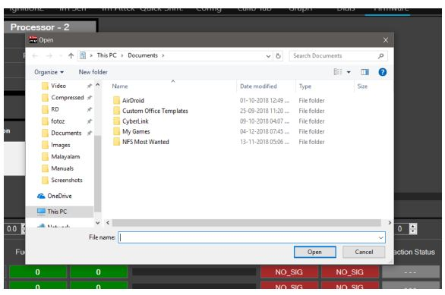

6. The firmware upgrade process will start automatically. Refer the Image below.
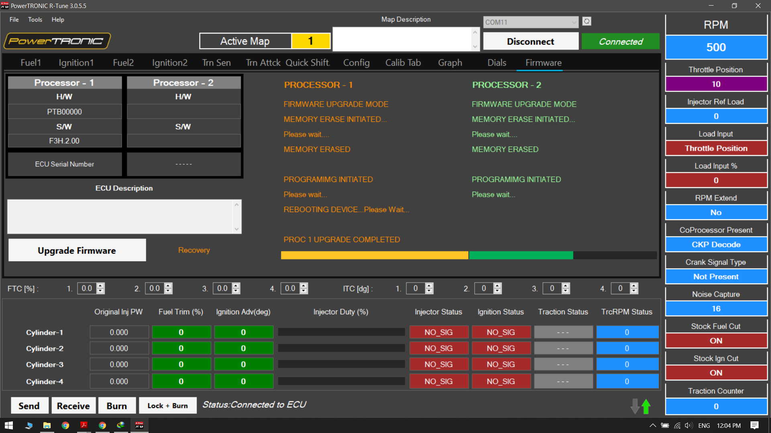

Caution: Upgrading the ECU would wipe all existing data on the ECU. Please make sure you have a fully charged battery or are connected to a power source in order uninterrupt the process.

7. Once the upgrade process is finished, remove the USB from Desktop/Laptop and Connect again.

8. You can verify the version of firmware version after reconnecting and receiving data from ECU. Refer the image below.

---/End of Document/---

