Lambda / Oxygen$(O_{2})$ Sensor Override

Document Version | 1 | Release Date | 20 March 2019

Application information | Vehicle Specific
Vehicle | Royal Enfield (EFI)
Model | BS IV compliant models.
Year of manufacture | 2018 onwards
PowerTRONIC application | All PowerTRONIC ECUs, from firmware version F.3.x onward

Note:

- Read through all instructions before installation and use.
- Ensure that the bike is switched off and the key is out of the ignition before proceeding with the installation.
- Some parts of the bikes might be hot/sharp and may cause burns/cuts. Proceed with extreme caution or wait until the bike has cooled down. Always wear safety gloves.
- When the installation is complete, make sure to secure the wiring loom away from the movable parts or components which tends to heat up during the normal operation of the vehicle at any chance.
- PowerTRONIC is intended for motorsport use on a closed course, please check with your local laws before using this product. Race Dynamics / PowerTRONIC is not liable for consequences arising out of using the product.

Support

Call/Whatsapp: +91 99162 29292 / +91 80409 29292
E-Mail: support@powertronicECU.com
Website: www.powertronicECU.com

Oxygen or Lambda sensor override

- Remove the fuel tank. Carefully detach all the connections related to the fuel tank.
- Locate the O2 (Lambda) sensor on the exhaust line. Refer the image.
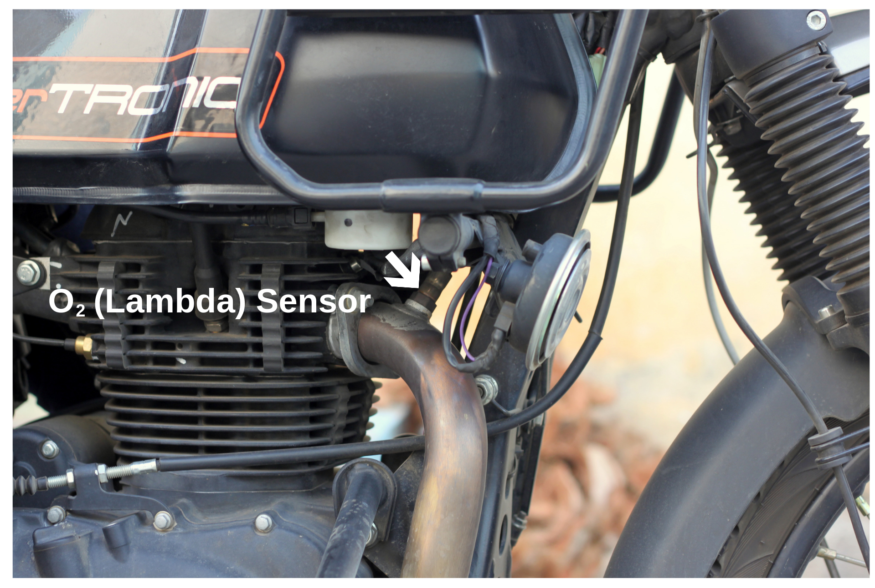
- Trace the O2 sensor connector, usually found below the fuel tank. Disconnect the connector
- Connect the provided override harness( Fig A) by connecting inline with the male and female terminals of the disconnected factory connector. (Refer Fig B for connected position)

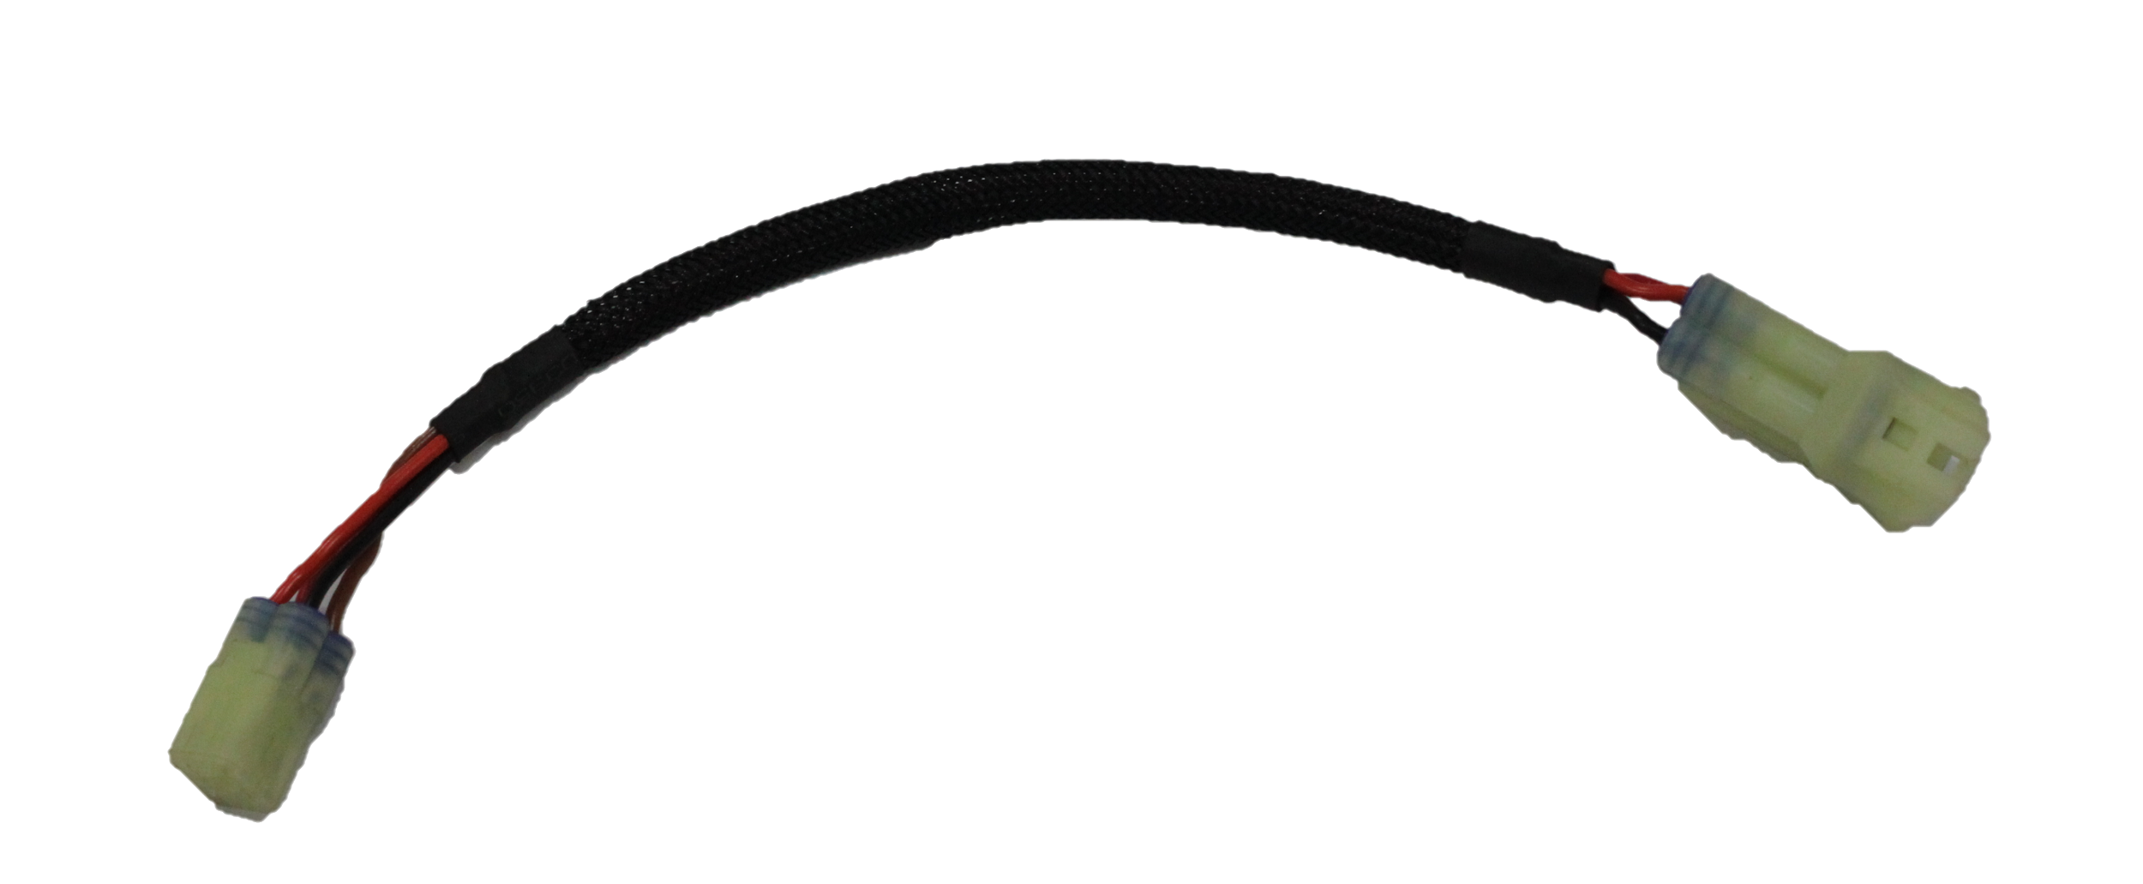

Fig A
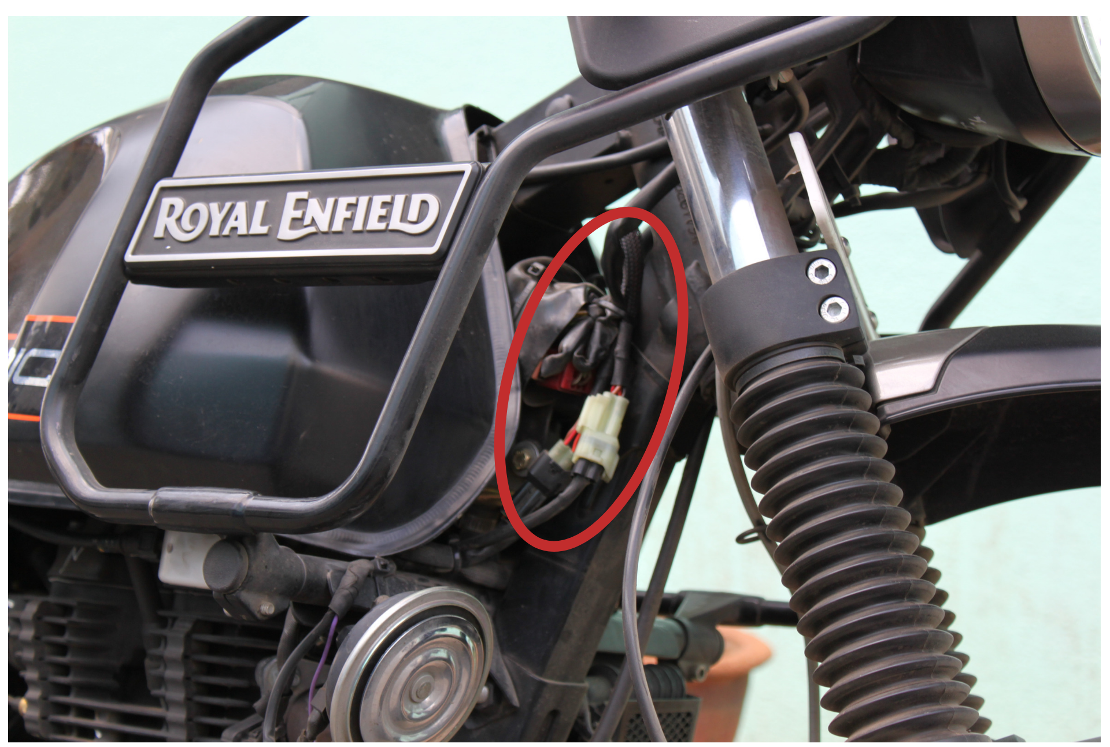Fig B

- Secure the harness using nylon tags to the chassis. Fix the fuel tank and all its related connections.

